Visual Narrative research
Visual Graphic Design
http://studioalexander.co.nz/site_images/Ac-Visual-Narrative.jpg
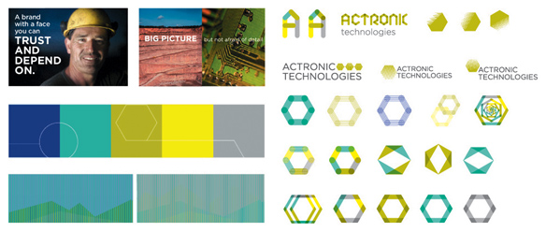
http://www.uwl.ac.uk/sites/default/files/Academic-schools/Ealing-School-of-Art-Design-and-Media/graphics%2050.jpg
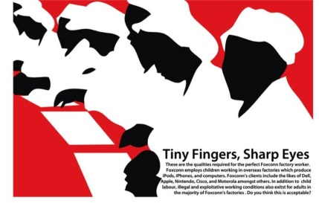
Visual narrative photography
http://media.tumblr.com/tumblr_lxh3pqk1Pz1qfbvb5.jpg
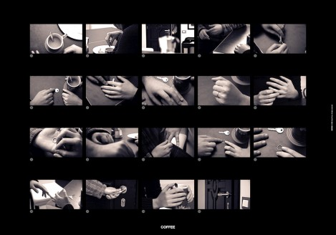
Visual Storytelling
http://payload.cargocollective.com/1/0/2101/2158745/IMG_6868.JPG
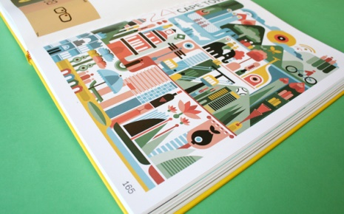
http://mattsoncreative.com/blog/wp-content/uploads/2011/10/mattson-creative-visual-storytelling-02.jpg
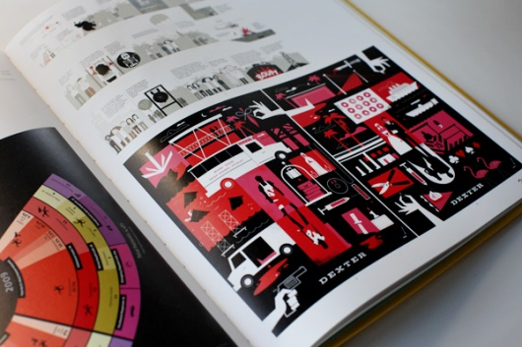
http://www.drewsmarketingminute.com/images/2011/09/benz2-1024x724.jpg

Narrative of Green tea (Draft)
Chapter one –
- How is green tea came about
- Ming dynasty and the way green tea became a golden thing – porcelain and fine china pottery - how it affected the western side of the world
- Ceremonies – traditions (tea drinking custom)

Chapter two -
- Similar tradition in tea drinking in British culture
- The uses of green tea in eastern and western part of the world
- Transition from green tea leaf to portable tea bags
- Reason behind it (fast pace: slow pace, profitable, taste, different environment, portability)
- How green tea is interpret in the western culture
- How it transform and used differently
Chapter three -
- Problem occurring in the western culture about green tea (Pesticides)
- Advertisement
- The “beneficial” claims promoted
Chapter 4 –
- My personal
(Draft 2)
Chapter 1 (Intro and History)
Page 1 – Other tea growing region (http://www.teagschwendner.com/US/en/Tea_Growing_Regions.TG?activeID=1052&parent_id)
- India, Sir Lanka, Taiwan, Indonesia, China, Japan, Africa, brazil
Page 2 – looking different type of tea available in the world
Page 3 – Looking at specifically: green tea
Page 2 – where green tea original came from: China
- Picture of China Flag, China Map
Page 3 – What is green tea and the process of making green tea (http://iml.jou.ufl.edu/projects/fall05/hanna/flowcharthome.gif)
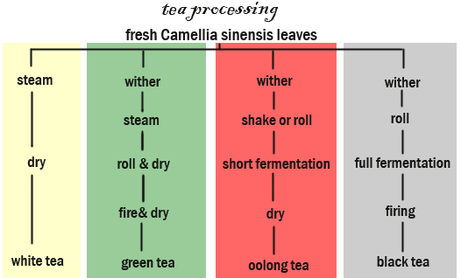
Page 3 – History of green in China – Ming Dynasty
Page 4 – Fine China Pottery
Page 6 – tradition involving tea drinking in china
Page 7 – Tradition in other country
Page 5 – different ways of drinking green tea (clear glass, Chinese pottery, British mug…)
Page 4 – What other main country grows green tea (http://geography.about.com/od/economic-geography/a/Geography-Of-Tea.htm)
- Biggest grower in the world is China, Second is Japan but over the year green tea become more significant in Japan Modern culture
Page 5 - How green tea tradition to modern technology (mocha, ice cream, beauty products)
Page 6 – Comparing to the slow life before Morden time in China
Page 7 – green tea converting/changing into portable, fast pace

Chapter 2 – Problem in the society about Green Tea
Page 8 – Problem of making green tea portable and fast
Page 9 – Pesticides used in green tea and the effects (report - http://www.cbc.ca/news/canada/pesticide-traces-in-some-tea-exceed-allowable-limits-1.2564624 )
Page 10 – Problem in Britain – Lipton (big company and no 1 company with highest uses)
Page 11 – advertisement
Page 12 – false/ not proven benefit of green tea (awareness)
Green tea in bottle promoted more to be health to the public and people don’t know what is in the green tea and if

Chapter 3 or Chapter 4 – Introduction and re communication of green tea (Important please read)!!!!!
As Chinese descendant living in Britain I have experience mixed culture in different things. I have focus my project on green tea due to loving green tea, my family has a strong bond around green tea and also interesting to see what I can re communicate to the British public.
Tea has become the meaning of bring people together at one moment in time, to enjoy company in both culture but however green tea is portrayed as a health benefit type of drink, then like normal British black tea where its advertised on TV as tea you drink with people. So I want to re communication green tea to the British public, that green tea should be advertise as a drink to drink with company and gathering or tea party, not only just a health tea drink which is currently and mostly portrayed as in the western culture. All so with re communicating green as a drink to drink with people, I also wanted to promote the idea of drinking loose green tea and keep the traditional ways of drinking green tea, because the problem now company like Lipton is promoting their “green tea product as a “healthy drink” which is not the case because of the over the maximum limit of pesticide in their green tea production according to research I seen on the internet and the high level of sugar contain in each bottle. They claim to have antioxidant which by far, loose green tea has the most and effective antioxidant provided in tea. Lipton is one of the biggest companies in bottled Green tea and tea bag green tea and promoted and advertises and so is very available to the public to drink and not be aware of this problem. I must admit I have drink Lipton few time and definitely was not aware of this situation and will definitely not purchase from them, knowing all the facts about their green tea.

Reference of images
Background
- http://sciencelakes.com/data_images/out/14/8812953-green-smoke-background.jpg
- (Logo) http://cdn.vectorstock.com/i/composite/91,25/green-tea-vector-1059125.jpg
Map of India
- http://www.lonelyplanet.com/maps/asia/india/map_of_india.jpg
Map of Africa
- http://www.mapsofworld.com/africa/maps/africa-map.gif
Map of Sir Lanka
- http://www.lonelyplanet.com/maps/asia/sri-lanka/map_of_sri-lanka.jpg
Map of Taiwan
- http://www.lonelyplanet.com/maps/asia/taiwan/map_of_taiwan.jpg
Map of Indonesia
- http://www.lonelyplanet.com/maps/asia/indonesia/map_of_indonesia.jpg
Map of Brazil
- http://www.lonelyplanet.com/maps/south-america/brazil/map_of_brazil.jpg
Map of Japan
- http://www.lonelyplanet.com/maps/asia/japan/map_of_japan.jpgv
Black tea
- http://www.blackteashop.co.uk/data/uploads/black-tea-leaves-online.jpg
Green Tea
- http://worldoftea.org/wp-content/uploads/2012/02/IMG_5377.jpg
White Tea
- http://www.jenierteas.com/components/com_virtuemart/shop_image/product/whit2dov_1000.jpg
Oolong Tea
- http://upload.wikimedia.org/wikipedia/commons/a/a1/Qi_Lan_Oolong_tea_leaf.jpg
Infusion of Herbal Tea
- http://media.tumblr.com/1169fde1def32e3f066edf7351498c68/tumblr_inline_mjzchjLMhL1qz4rgp.png

Selection of Infusion plants
- https://www.octaviatea.com/teaguide/Images/herbal-teas-wood-box.jpg
Chinese Flag
- http://www.worldstatesmen.org/cn.gif
Map of China
- http://www.lib.utexas.edu/maps/middle_east_and_asia/china_specialec_97.jpg
Green Tea
- Original image –
Green Tea in Chinese
- https://translate.google.co.uk/#auto/zh-TW/Green%20Tea
Camellias Plant
- http://sushinow.com/pics/supplies/Tea-Leaves-Picked.jpg
Women freshly picking Camellias Plant
- http://www.theteatalk.com/images/D_pink_hat_picker.jpg
Camellias Wither
- http://www.discoveringtea.com/wp-content/uploads/2010/07/th%C3%A9s-blancs-fl%C3%A9trissage.jpg
Steam
- http://maruyamaseicha.co.jp/en/img/steam.jpg
Roll and Dry
- http://www.inpursuitoftea.com/v/vspfiles/assets/images/twisting_sencha1.jpg
Fire/ Heated Process
- http://www.esgreen.com/blog/wp-content/uploads/2011/07/20080329141952199-300x2251.jpg.pagespeed.ce.bpnTHDiBtW.jpg
Package
- http://3.bp.blogspot.com/_CKlp--MhSA0/TPkzRFTRk_I/AAAAAAAAAUA/QFN1eJpOLMg/s400/oriental+beauty+factory.JPG
Medicine Image
- http://www.soundsourcery.com/tjm/images/chinese_herbs.jpg
Old Chinese drama
- http://history.cultural-china.com/chinaWH/upload/upfiles/2010-03/22/mei_ren_xin_ji_schemes_of_a_beauty__historical_period_drama_on_empress_dou_yifang_of_western043756e6bca46d9685e4.jpg
Lu “tea classic script”
- http://www.myjapanesegreentea.com/wp-content/uploads/2012/03/The-classic-of-tea.jpeg
Lu yu statue
- http://blog.taiwan-guide.org/wp-content/uploads/lu-yu-god-of-tea.jpg
New sign
- http://seasonalcycles.homestead.com/SignNew.jpg
Around the world
- http://www.cafinternational.com/images/globe-with-arrow.jpg
Tea drinking in Tang Dynasty
- http://www.viconyteas.com/directory/tea-encyclopedia/tang-tea-drinking.html
Ming D , abolish Cake tea
- http://www.rivertea.com/blog/wp-content/uploads/2013/03/Disk-Shaped-Pu-erh-e1362141838925.jpg
Song Emperor
- http://en.wikipedia.org/wiki/File:Song_Taizu.jpg
Whipped power green tea – men drinking
- http://images.china.cn/attachement/jpg/site1007/20110808/00114320def10fa9e46118.jpg
Powder
- http://knoji.com/images/user/matcha-green-tea.jpg
Dragon/ Phoenix tea cake
- http://img01.cp.aliimg.com/bao/uploaded/i3/250437444/T2kIqFXf4XXXXXXXXX_!!250437444.jpg
Chinese tea Bowl
- http://photos1.blogger.com/blogger/391/134/1600/DSCN1791.jpg
Ming Emp
- http://en.wikipedia.org/wiki/File:%E6%98%8E%E5%A4%AA%E7%A5%96.jpg
Lose tea leaves
- http://upload.wikimedia.org/wikipedia/commons/e/ef/English_Westminster_Tea.jpg
Porcine pot
- http://www.metmuseum.org/toah/images/h2/h2_37.191.1.jpg
Respect cartoon
- My own creation
Family Gathering
- http://www.chinadaily.com.cn/opinion/images/attachement/jpg/site1/20130208/00221917e13e127e80d403.jpg
Wedding
- http://3.bp.blogspot.com/_VF87N2A--ro/TLr9rEaMHgI/AAAAAAAAAIs/7ez_uMqAhI4/s1600/cartoon-01.jpg
Child severing tea to parent
- Own image
Yum Cha
- http://3.bp.blogspot.com/_bOmcj61GL7g/TK1k7wa4qZI/AAAAAAAAAoc/yRUqaUyaB3s/s400/Sunday+Yum+Cha_RGB.jpg
wedding tea pouring
- http://thumbs.ifood.tv/files/images/editor/images/Tea%20ceremony.jpg
Dim sum and Yum Cha (gathering_
- http://www.chinatourguide.com/china_photos/hongkong/dining/Hongkong_dim_sum_e.jpg
First coffee shop 1650
- http://sisucg.files.wordpress.com/2010/10/cafe_tv3.jpg
Coffee shop 1652
- http://qph.is.quoracdn.net/main-qimg-7b185a02cf437044c7b70c3abe630de3?convert_to_webp=true
tea in the 1600
- http://www.stmgrts.org.uk/images//COFFEE_Coffee_House_1660.jpg
British Flag
- http://media.gizmodo.co.uk/wp-content/uploads/2013/01/british-flag.jpg
Office drinking tea
- http://static.guim.co.uk/sys-images/Money/Pix/pictures/2012/6/28/1340893010764/Business-people-drinking--007.jpg
Three girls drinking tea
- http://i.telegraph.co.uk/multimedia/archive/02196/B36D5H_2196941b.jpg
Builders drinking tea
- http://news.images.itv.com/image/file/345630/article_img.jpg
Tea party
- http://3.bp.blogspot.com/-0noTCqbBGCY/T4rr0ElrNLI/AAAAAAAAiHA/COVE8QxnhDQ/s1600/080.JPG
Family drinking tea (breakfast)
- http://blog.ideales.gr/wp-content/uploads/FAMILY-BREAKFAST1.jpg ]
Page 17 all my photo of green tea
- Original image
Fast pace people
- http://static.guim.co.uk/sys-images/Guardian/Pix/pictures/2012/6/27/1340809328417/People-going-to-work-008.jpg
Fast train
- http://www.ermlegalsolutions.com/wp-content/uploads/2012/03/fast-train.jpg
Portable
- http://images.davidstea.com/products/EN/carry-travel-mug-ice-blue-901103-noFlakes_l.png
Sweeter (sugar)
- http://stayhealthyla.org/blog/uploads//2010/03/sugar.jpg
Busy London
- http://graphics.tudelft.nl/~cpbotha/thingies/oxford_street-27_dec.jpg
Calm China
- http://images.china.cn/attachement/jpg/site1007/20120424/001422373e1911008d6f63.jpg
Tea cup British and Chinese
- My own Images
Green tea ice cream
- http://www.japanesecooking101.com/wp-content/uploads/2013/08/IMG_0223.jpg
Green tea cake
- http://chauvestyle.com/wp-content/uploads/2012/05/greenteamoussecake-28.jpg
Green tea kit kat
- http://inventorspot.com/files/blog1/kitkat-chocolate.jpg
Green tea starbuck
- http://data3.whicdn.com/images/50552949/large.jpg
Macaroon
- http://hopesdreamsaspirations.files.wordpress.com/2012/05/dsc_1053-blog1.jpg
Beauty product
- http://static.hk.groupon-content.net/12/84/1339757368412.jpg
Problem sign
- http://www.blackbaudknowhow.com/wp-content/uploads/2012/07/problem.jpg
Tea tasting Varity
- http://www.experiencetravelgroup.com/blog/wp-content/uploads/2012/04/tea-tasting.jpg
People tea tasting
- http://partner.dilmahtea.com/admin/pressroom/uploads//The-Chefs-and-the-Teamaker-2008-The-Team-Tasting-Tea-at-Dilmah-Tea-Head-Office.jpg
Bitter taste face
- http://thumbs.ifood.tv/files/images/bitter_taste1.jpg
Sweet taste (lips)
- http://www.moveoneinc.com/blog/wp-content/uploads/2011/08/Sweet-taste.jpg
Lipton green tea
- http://moonlightxmarionette.files.wordpress.com/2011/10/file_15_55.jpg
Green tea Lipton tea bag box
- http://taw9eel-media.r.worldssl.net/media/catalog/product/cache/1/image/800x/9df78eab33525d08d6e5fb8d27136e95/9/_/9_52.jpg
Pesticides
- http://www.wantchinatimes.com/newsphoto/2012-05-21/450/C518X0446H_2012%E8%B3%87%E6%96%99%E7%85%A7%E7%89%87_N71_copy1.JPG
Green tea in glass cup (show healthy)
- http://www.myessentia.com/blog/wp-content/uploads/2013/06/green-tea.jpg
Lipton advert
- http://www.webdesignbooth.com/wp-content/uploads/2009/07/lipton-green-tea.jpg
- http://m1.behance.net/rendition/modules/51986607/disp/52b12d557813284d9a08b2841254072b.jpg
- http://m1.behance.net/rendition/modules/7184909/disp/b9fd7bffec9ff44ccefb18a9cbc1e9c6.jpg

Other reference for information
Wiki ref – (Find reference) (reading) (because there was no other full detail depth of the topics)
- Green tea - http://en.wikipedia.org/wiki/Green_tea
- Health effect of Tea - http://en.wikipedia.org/wiki/Health_effects_of_tea
- History of Tea - http://en.wikipedia.org/wiki/History_of_tea
- History of Tea in China - http://en.wikipedia.org/wiki/History_of_tea_in_China
- Tea in the UK - http://en.wikipedia.org/wiki/Tea_in_the_United_Kingdom
Geography of tea - http://geography.about.com/od/economic-geography/a/Geography-Of-Tea.htm
Tea in Britain - http://www.britainexpress.com/History/tea-in-britain.htm
Tea growing Region - http://www.teagschwendner.com/US/en/Tea_Growing_Regions.TG?activeID=1052&parent_id=
Tea Article – Green Tea - http://www.revolutiontea.com/tea-articles/green-tea-history.html
Process of steaming and packing – http://theorganicbeauty.files.wordpress.com/2013/02/images-51.jpg
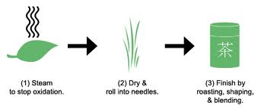
Different tea - http://www.teapalace.co.uk/Different-Types-of-Tea-Adifferent/
Tea in Britian
- http://www.britainexpress.com/History/tea-in-britain.htm
History green tea and info
- http://www.revolutiontea.com/tea-articles/green-tea-history.html
Tea history (green tea)
- http://www.teavivre.com/info/green-tea-history/
Tang D – Drinking tea
- http://www.viconyteas.com/directory/tea-encyclopedia/tang-tea-drinking.html

Info of brewing green tea in song d
- http://www.china.org.cn/learning_chinese/Chinese_tea/2011-07/15/content_22999489.htm
Song D
- http://www.tching.com/2010/05/your-own-personal-tea-ceremony/
Reading list (reference)
Chinese Tea culture
- http://en.wikipedia.org/wiki/Chinese_tea_culture
health and effect of tea
- http://en.wikipedia.org/wiki/Health_effects_of_tea
History of Tea
- http://en.wikipedia.org/wiki/History_of_tea
History tea in china
- http://en.wikipedia.org/wiki/History_of_tea_in_China
Tea in the Uk
- http://en.wikipedia.org/wiki/Tea_in_the_United_Kingdom
LU YU
- http://en.wikipedia.org/wiki/Lu_Yu
Tea history – ming, tang ,
- http://www.teavivre.com/info/green-tea-history/
Tea drinking history
- http://www.viconyteas.com/directory/tea-encyclopedia/chinese-tea-drinking.html
Tea in Britain
- http://www.britainexpress.com/History/tea-in-britain.htm
History of tea
- http://www.china.org.cn/learning_chinese/Chinese_tea/2011-07/15/content_22999489.htm
Quotes about China
- http://www.brainyquote.com/quotes/keywords/china.html

